ECRMDP - Unified Customer 360 & Sales Analytics Platform

System Architecture
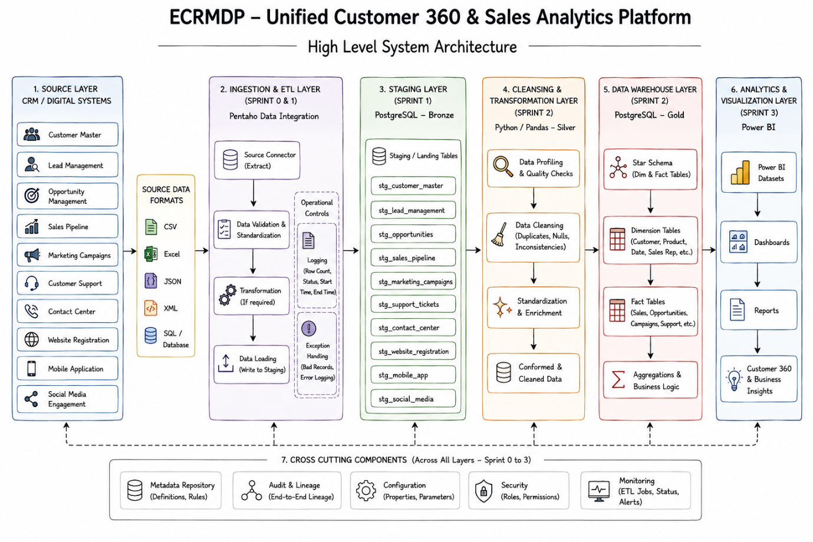

High-Level System Architecture Explanation
The ECRMDP – Unified Customer 360 & Sales Analytics Platform follows a layered architecture designed to collect data from multiple CRM and digital sources, process and standardize the data, store it in a centralized data platform, and finally provide business analytics and Customer 360 insights. The architecture represents the complete project flow from source systems through ingestion, staging, cleansing, data warehousing, and analytics.
1. Source Layer – CRM / Digital Systems
The Source Layer is the starting point of the platform. It contains the different CRM and digital systems that generate customer and business-related information.
The architecture considers the following major sources:
- Customer Master
- Lead Management
- Opportunity Management
- Sales Pipeline
- Marketing Campaigns
- Customer Support
- Contact Center
- Website Registration
- Mobile Application
- Social Media Engagement
These systems may produce data in different formats, so the platform must be capable of handling heterogeneous data sources.
2. Source Data Formats
The source data can be received in multiple formats, including:
- CSV
- Excel
- JSON
- XML
- SQL / Database
The ability to handle multiple formats allows the platform to integrate information from different systems without requiring all source systems to use the same data format.
3. Ingestion & ETL Layer – Pentaho
The second major layer is the Ingestion & ETL Layer, which uses Pentaho Data Integration.
The purpose of this layer is to extract data from the different source systems, perform the required validation and processing, and load the data into the staging environment.
The main ETL flow is:
Source Connector → Data Validation & Standardization → Transformation → Data Loading
Source Connector
The Source Connector extracts data from the different source formats such as CSV, Excel, JSON, XML, and SQL databases.
Data Validation & Standardization
The extracted data is checked and standardized before being loaded into the database. This helps ensure that the incoming data follows the expected structure and basic quality requirements.
Transformation
Required transformations can be performed during the ingestion process. These transformations prepare the data for loading into the staging layer.
Data Loading
After processing, Pentaho loads the data into the PostgreSQL staging tables.
Operational Controls
The ETL layer also contains operational controls:
Logging records information such as:
- Row counts
- Processing status
- Start time
- End time
Exception Handling is used to identify and handle:
- Bad records
- Processing errors
- Ingestion failures
- Error logging
These controls improve the reliability and traceability of the ETL process.
4. Staging Layer – PostgreSQL Bronze
The next layer is the PostgreSQL Bronze/Staging Layer.
This layer acts as the centralized landing area for the data received from the ETL processes. Data is stored in separate staging tables based on the source system.
Examples shown in the architecture include:
- stg_customer_master
- stg_lead_management
- stg_opportunities
- stg_sales_pipeline
- stg_marketing_campaigns
- stg_support_tickets
- stg_contact_center
- stg_website_registration
- stg_mobile_app
- stg_social_media
The Bronze layer preserves the incoming data in a structured staging environment and provides the foundation for subsequent cleansing and transformation.
5. Cleansing & Transformation Layer – Python / Pandas Silver
The next stage is the Cleansing & Transformation Layer, represented as the Silver layer.
This layer is responsible for improving the quality and consistency of the data before it is used for analytical purposes.
The architecture includes:
Data Profiling & Quality Checks
The incoming staged data is examined to identify quality issues and understand the characteristics of the data.
Data Cleansing
Typical issues addressed at this stage include:
- Duplicate records
- Missing or null values
- Data inconsistencies
- Invalid or inconsistent values
Standardization & Enrichment
Data is standardized into consistent formats and can be enriched with additional information required by the business.
Conformed & Cleaned Data
After cleansing and standardization, the resulting data becomes consistent and suitable for loading into the data warehouse.
The architecture represents Python/Pandas as the technology used for this processing layer.
6. Data Warehouse Layer – PostgreSQL Gold
The cleaned data then moves into the Data Warehouse Layer, represented as the Gold layer.
The architecture uses PostgreSQL for the Gold data warehouse.
The warehouse follows a structured analytical model containing:
Star Schema
The architecture uses a Star Schema consisting primarily of:
- Dimension Tables
- Fact Tables
Dimension Tables
Dimension tables provide descriptive information used for analysis. Examples shown in the diagram include:
- Customer
- Product
- Date
- Sales Representative
Fact Tables
Fact tables contain measurable business events and transactions, such as:
- Sales
- Opportunities
- Marketing Campaigns
- Support activities
Aggregations & Business Logic
Business calculations and aggregations are applied to make the warehouse data suitable for reporting and analytics.
The Gold layer therefore acts as the business-ready analytical data layer of the platform.
7. Analytics & Visualization Layer – Power BI
The final layer is the Analytics & Visualization Layer, implemented using Power BI.
The Gold data warehouse provides the data required by Power BI.
The flow is:
Gold Data Warehouse → Power BI Datasets → Dashboards → Reports → Customer 360 & Business Insights
Power BI Datasets
Datasets provide the analytical data required by reports and dashboards.
Dashboards
Dashboards present important business metrics and trends in an interactive visual format.
Reports
Reports provide more detailed analysis of customer, sales, marketing, and support-related information.
Customer 360 & Business Insights
The final objective is to provide a unified view of customers and generate meaningful business insights that can support decision-making.
8. Cross-Cutting Components
The architecture also contains Cross-Cutting Components that support multiple layers of the platform rather than belonging to a single processing stage.
Metadata Repository
Stores definitions, rules, and other metadata required for managing the data platform.
Audit & Lineage
Provides end-to-end visibility of where data originates and how it moves through the different layers.
Configuration
Stores processing properties and parameters used by the platform.
Security
Controls access through appropriate roles and permissions.
Monitoring
Provides visibility into ETL jobs, processing status, and alerts.
These components help improve the governance, security, traceability, reliability, and maintainability of the overall platform.
9. Overall Data Flow
The complete high-level flow of the system can be summarized as:
CRM / Digital Sources
↓
CSV / Excel / JSON / XML / SQL
↓
Pentaho Ingestion & ETL
↓
PostgreSQL Bronze / Staging
↓
Python / Pandas Cleansing & Transformation – Silver
↓
PostgreSQL Gold Data Warehouse
↓
Power BI
↓
Dashboards & Reports
↓
Customer 360 & Business Insights
This architecture provides a clear separation between raw data ingestion, data quality processing, analytical storage, and business visualization.
10. Sprint-wise Architectural Mapping
The architecture also maps the major technical layers to the project's sprint progression:
Sprint | Major Architectural Focus
Sprint 0 | Project initiation, requirements, scope, repository, backlog, architecture and project foundation
Sprint 1 | Source discovery, Pentaho ingestion, validation, PostgreSQL Bronze/Staging, logging and exception handling
Sprint 2 | Data profiling, cleansing, standardization, enrichment, Silver layer and Gold data warehouse
Sprint 3 | Analytics, Power BI dashboards, reports, Customer 360 insights, governance, monitoring and final integration
The diagram therefore represents the complete high-level architecture of the project, while the implementation progresses incrementally across the four sprints.

Architecture Summary
The proposed architecture establishes an end-to-end data pipeline in which heterogeneous CRM and digital data is collected, ingested through Pentaho, stored in PostgreSQL Bronze, cleansed and standardized into the Silver layer, organized into a Gold data warehouse, and finally consumed through Power BI for dashboards, reports, and Customer 360 business insights. Cross-cutting capabilities such as metadata management, audit and lineage, configuration, security, and monitoring support the platform across all architectural layers.

